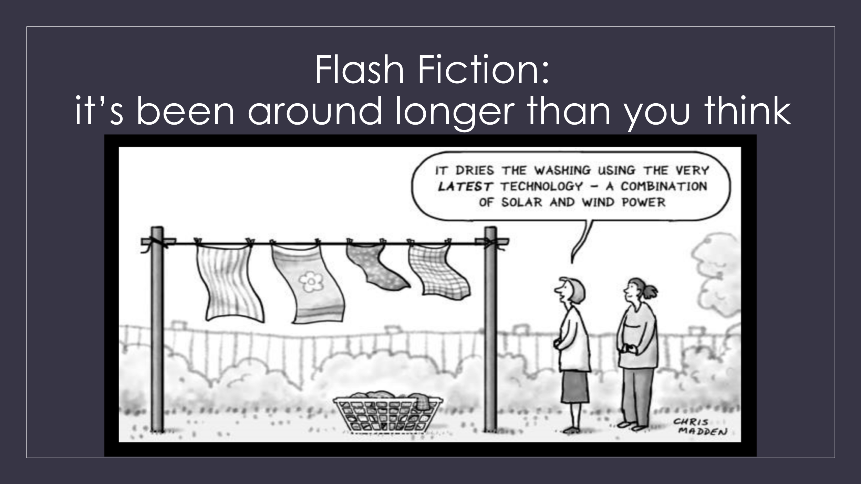

**Flash Fiction FUNdamentals**

Flash fiction may sound new and alien, but it’s been around longer than you think. The query that inspired the first flash fiction contest was, “How short can a short story be and still be a short story?”

As a result, [Short Stories From *Life*](https://www.gutenberg.org/files/68085/68085-h/68085-h.htm) was published in 1916, featured81 stories fromthe Shortest Story Contest. Further questions raised as the project grew were:

* When is a story not a story, but only an anecdote?
* When a story is a story, is it a combination of plot, character, and setting, or is it determined by only one of these three elements?
* Must it end when you have ended it or must it suggest something beyond the reading?

These are still some of the questions asked about flash fiction, but let’s clarify.

WHAT IS FLASH FICTION?

* Flash Fiction is a form of short story, usually between 300 to 1,000 words.
* It must be complete in itself—a full narrative arc, containing a struggle of some sort between two opposing forces.
* There needs to be a goal with real consequence.
* You should have a beginning that will hook the reader, a middle that engages them, and a satisfying ending.

WHY WRITE FLASH FICTION?

* You get to play with a new story!
* It’s a good way to push past writer’s block—and writing prompts are a fun way to jumpstart creative juices.
* You’ll get used to editor redlines and publisher deadlines. (also Track Changes)
* You’ll experience the rush of finishing!
* You’ll learn to write and edit tighter.
* You’ll create content (aka lead magnets) to offer your readers.
* You can be published faster.

Publishing flash fiction is not automatic, but the barrier to entry is not as steep as it is for a full-length novel.

HOW TO WRITE FLASH FICTION.

Getting down to business

Every story needs a beginning, a middle, and an end whether it’s spread over a seven-book series or a 50-word fiction. You need a beginning that will hook the reader, a middle that engages them, and a satisfying ending. And you need to do that in 1,000 words.

Basic Structure for Plotters

For plotters, here’s a basic structure for a 1,000-word flash fiction story. I’m pretty committed to pantsing—but people who plot say this is helpful.

* Intro: ~ 150 words to introduce the setting and characters. If you can, start in the middle of the crisis and imply previous try-fails
* Rising action: ~ 600 words to develop the main conflict (continued try-fails, conflict/crisis)
* Climax: ~ 200 words to share the turning point/most intense moment.
* Resolution: ~ 50 words to reveal a satisfying ending or twist.

**Beginnings**

* Pay attention to submission requirements.
* Make your title earn its keep! It’s not included in your word count, so use it to set the stage or foreshadow a twist.
* Your first line needs to hook the reader.
* Pay attention to POV and voice (whether you choose 1st, 2nd, or 3rd)
* Limit your characters to one or two–but include the conflict of two opposing forces
* Introduce the setting. Let us feel your world. Use your senses. When you introduce a feature, make sure it’s pertinent to the plot

Writing prompts are a fun way to get started.

* Check out upcoming themes for contests (Havok, Spark, NYC Midnight)
* Reedsyprompts https://blog.reedsy.com/creative-writing-prompts/
* Story Dice

Here are some of my favorite openings:

“There are things they don’t tell you about having green skin.”

*Photosynthetic* by Cassandra Hamm

“Buzzing speakers scrape at my nerves as decrepit shocks collide with Boston’s finest potholes. The cab barrels down Newbury Street. He’s not stopping. He’s not even slowing down.”

*Trumpet Blues* by Sophia Hansen

“I did not have a name—none of us did—but once when I was young, I had a friend.”

*RECORDER* by Cathy McCrumb

Commander Tri’eek’s ship was self-destructing.  
Bianca muttered Earth English curses under her breath as she ran through the*Argo’s* gigantic ventilation shafts, holding a gargantuan stolen ring of shiny, black electrical tape around her waist like a life ring. She had spent three precious hours tracing the problem to the engine maintenance room. She couldn’t afford to be wrong.

*Brownie Points* by Lavender Ellington

**Middle**

*The story doesn’t start until something goes wrong* - Steven James

* Dialogue, dialogue, *dialogue*
* Action beats can reveal more about your characters than dialogue tags
* Reveal, don’t lecture (aka show, don’t tell)
* Avoid talking heads. Use the whole body to communicate your character’s state of being—shoulders, fingers, knees, toes
* What are the stakes? What happens if the MC fails? Will the reader care?

**End**

* Foreshadowing: Your readers want to know what’s going to happen but they also want to be surprised—so plant seeds of the ending in the beginning and throughout the story.
* Mirroring: An ending that reflects the beginning brings brings a full-circle satisfying sense of closure.
* Your ending needs to be satisfying and the conflict, resolved—whether it’s positive or negative. Leave your readers with a thought to chew on, a twist, or an aha. Does the story convey an idea larger than itself?

*N.B.*, in Short Stories From *Life*, gives the reader serious pause with their twist ending, as does the Sci-Fi classic, *To Serve Man*.

Finishing:

* Check for repeated words or concepts, unnecessary details, or cliches.
* Look out for repeated pronoun-verb openings.
* Read it out loud and get someone else to look at it.
* Recheck the submission requirements before hitting *SEND*!

Where to submit

* [Havok Publishing](https://gohavok.com/submission-guidelines/) wants stories that hit fast and strike hard––stories that can cut through the day’s troubles and grip distracted readers. They also provide feedback on all submissions, unless requested otherwise.
* [Spark Flash Fiction](https://sparkflashfiction.com/submission-guidelines/) looks for romance stories that will grab the reader and put a spark in their day.
* [NYC Midnight](https://www.nycmidnight.com/) hosts contest for a variety of short fiction stories. For a small entry fee they provide prompt-based challenges, feedback from their judges, and peer feedback forums.
* If you’re curious about flash fiction, read some! There are plenty of free sources and don’t take more than a few minutes of your time.
* [REEDSYPROMPTS](https://blog.reedsy.com/creative-writing-prompts/) has weekly writing prompts. Check out their faq for details.

Finally,

If you’re curious about flash fiction, read it!

There are plenty of free sources and they don’t take more than a few minutes of your time.

Resources:

* Brandon Sanderson: SHORT STORIES with Guest lecturer Mary Robinette Kowal  
  <https://www.youtube.com/watch?v=blehVIDyuXk>
* Grant Faulkner The Art of Brevity  
  <https://grantfaulkner.com/books/the-art-of-brevity/>   
  <https://youtu.be/K3VhXltVTtc?si=Lfxirn5oRzO8kmgm>

**Community**

Facebook

* Flash Fiction Writers Guild
* Flash Fiction Lovers

Instagram

* Search #gohavok