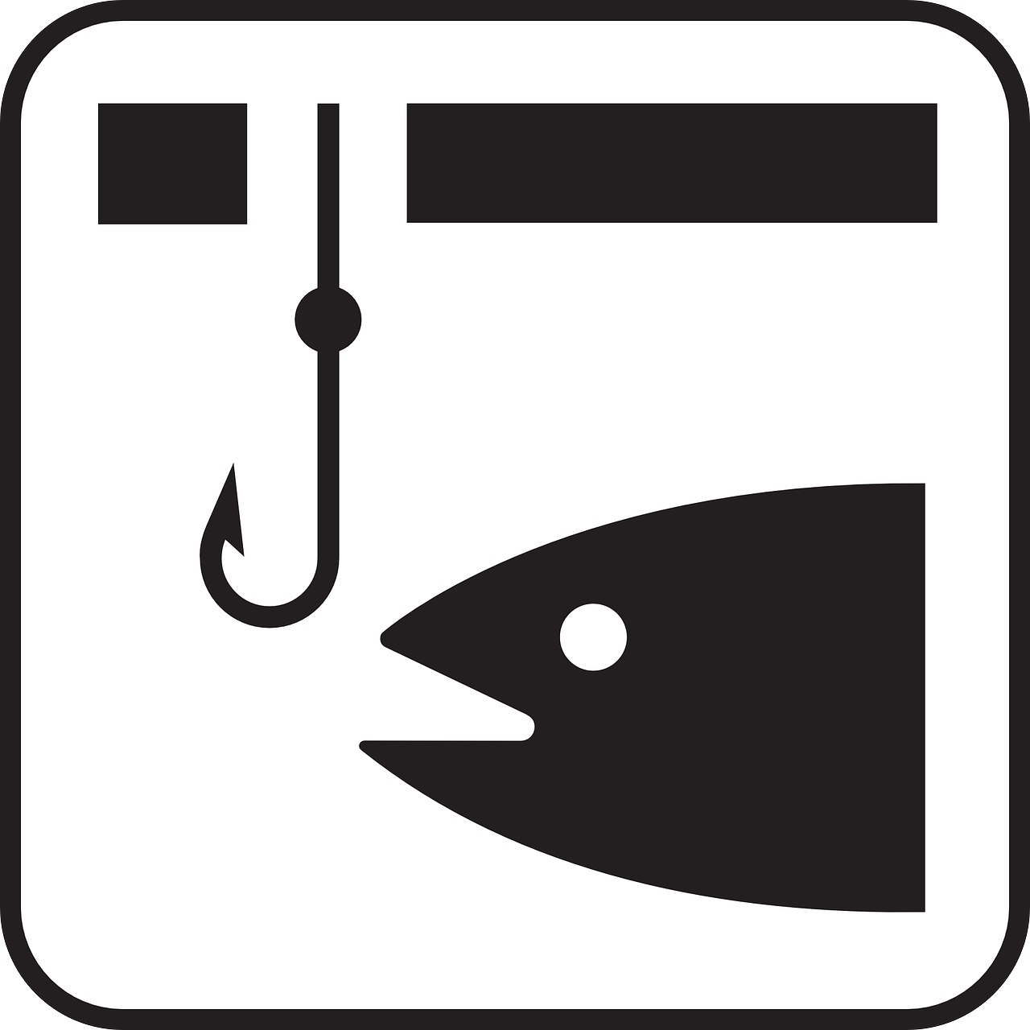
EVERY BOOK NEEDS A HOOK
© 2024 Cynthia Ruchti
cynthia@booksandsuch.com
FCWC

Grabbing a reader’s, editor’s, or agent’s attention depends heavily on the strength of your hook.
A hook isn’t just an elevator pitch, a quick pitch, and definitely NOT a summary of your story. It is the ________________________.
Book marketing expert Rob Eager says, “A book hook harnesses the power of _________________________________ to naturally make people notice and want more.”

FICTION: <insert person> must find/conquer/reveal/evade/solve <insert the item or foe or secret or mystery> before <insert what makes it a ticking time bomb> or <insert what’s at stake, why it could spell disaster>.
NONFICTION: Because <insert problem> creates <insert felt need> for <insert people group>, <insert answer the book provides>.

But templates usually mean that even if the elements themselves are intriguing, the format sounds like every other hook an editor has ever heard. And that makes the bait ______________________________________________________.
Authors sometimes think a hook is an afterthought. It’s a ________________________ _____________________________ thought.
Let’s look at several examples of ho-hum non-hooks:
- Two people need to save the world from disaster.
- A pair of unlikely heroes join forces to prevent a global disaster.
- Two sworn enemies join forces to prevent a rogue satellite from destroying all human life.
- Sworn enemies join forces to intercept a rogue satellite bent on human destruction, but one of them will have to die in the process, and neither is volunteering.

What makes a good hook?
- A young woman needs to find a way to preserve her grandfather’s legacy.
- A young investment advisor must save the family farm or risk losing her grandfather’s legacy.
- More accustomed to bilking unsuspecting investors than milking cows, Serena faces the end of her grandfather’s legacy—and the last remnants of her soul—if she fails to make good on the promise she made at his deathbed. From manipulation to manure, she’s stepping in it.
Or this one:
- An old man struggles in his trip across the Pacific.
- An old man sails solo across the Pacific to find himself.
- A man nearing the end of an unremarkable life takes to the sea to prove life was worth living anyway. Nature is out to prove him wrong.

Which would you want to read? Consider another set of examples, this time for nonfiction:
- Learning how to be generous is as easy as one, two, three.
- Generosity, like money, doesn’t grow on trees.
- What if changing one thing could change everything about your enjoyment of life, your relationship with others, and your ability to make a difference in your circle of influence? It can. God called it living generously.

A good hook definitely doesn’t give away the whole story, but it also doesn’t leave out either ____________________ or __________________.
A hook can also demonstrate the writer’s _____________________ from the start.
What thought-provoking questions does your hook prompt in your reader? For nonfiction, can you use a startling statistic to grip a reader’s attention?
A good hook tells the reader he or she is in for a good story, that the time investment will be worth it.
A hook might imply:
- recent, imminent or eventual ____________________
- compelling ____________________________________
- Interesting or rather irresistible _________________ or ____________________
- Or all of the above
Now Novel blog says it “can also be something as simply compelling as a lone, specific voice reaching out to us from the written page.”
Also from Now Novel’s blog, “Stories are about change…Nothing is an agent of change like conflict.”
An example that could have been taken from hurricane headlines: “In an instant, their mountain hideaway became an island of desperation with no way out for anything but hope.”
A good hook will set the story’s/book’s ___________________.
- Humorous or lighthearted?
- A book of discovery?
- Conversational and warm?
- Mysterious?
- Heartrending?
- Hopeful?
Think about your current project. Select three descriptors of tone for a hook sentence you’d like to write. They might be something like:
- Tense, unsettling, suspenseful
- Lyrical, thoughtful, comforting
- Gritty, fast-paced, heart-stopping
- Silly, quirky, romantic

Your descriptors:
________________________________________________________________

Write a sentence with your three adjectives in mind not as words to use but as concepts or tone. Yes, it can be two sentences, but work at it until you can make it one…and not a hundred-word sentence either.

It can’t sound like _______________________________. The reading public has had enough of that.
It can’t sound like __________________________________. They’ll see right through it.
It can’t make the reader mentally _________________________________.
It can make the reader think, “How are they going to make that happen?” or “How will this play out?” or “What an interesting concept!” but it can’t make the reader say, “________________________”
What to avoid when creating your book’s hook:
- Making the statement _________________________________________________. If it sounds like a book you’ve already read, try again.
- ______________________________ that the reader needs to purchase the book to discover.
Will retired used car salesman Chuck Boris find a reason to keep on living after his wife dies suddenly in the last car he sold?
- ______________________________________. Curiosity can be taken too far.
She dreamed of this day. He dreaded it. They found a way.
- __________________________________________. “The best story you’ve ever read with the most compelling characters ever created.” Or…”The single, exceptional, invigorating, can’t-miss tip that will reduce all your debt before the end of the day.”

The purpose of a hook is NOT to ________________________________. It is to ____________________________________the reader’s interest in your book.

Jack Jordan, The Novelry:
“Crucially, (a great hook) also helps you, the author,
know if you have a strong idea on your hands.”

How to write a great hook for your novel
- What the book is about
- Who the book is about
- What is at stake
“An organized crime ring abducts the child of a leading heart surgeon and gives her an ultimatum: kill a patient on the operating table or never see her son again. Which is stronger: a doctor’s oath? Or a mother’s vow to protect her child?”— Jack Jordan’s hook for Do No Harm
‍Let’s practice.

