 |  | 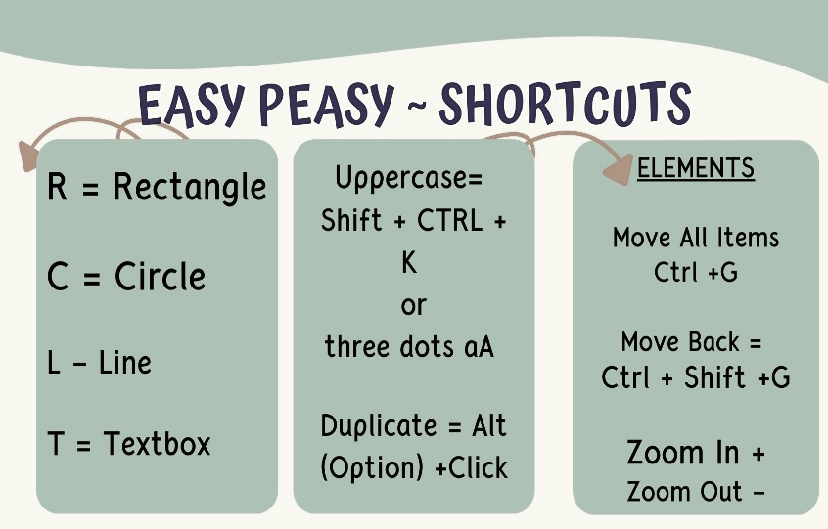
    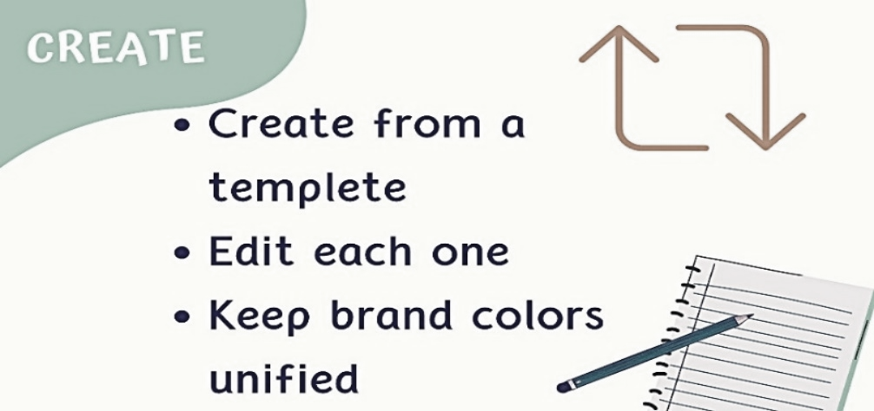 | 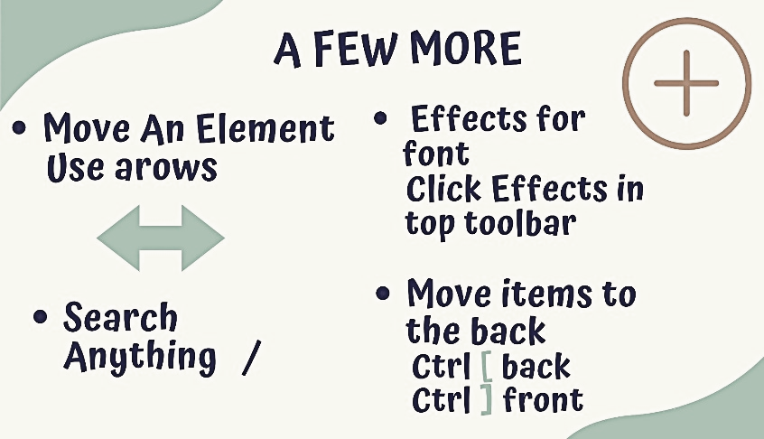  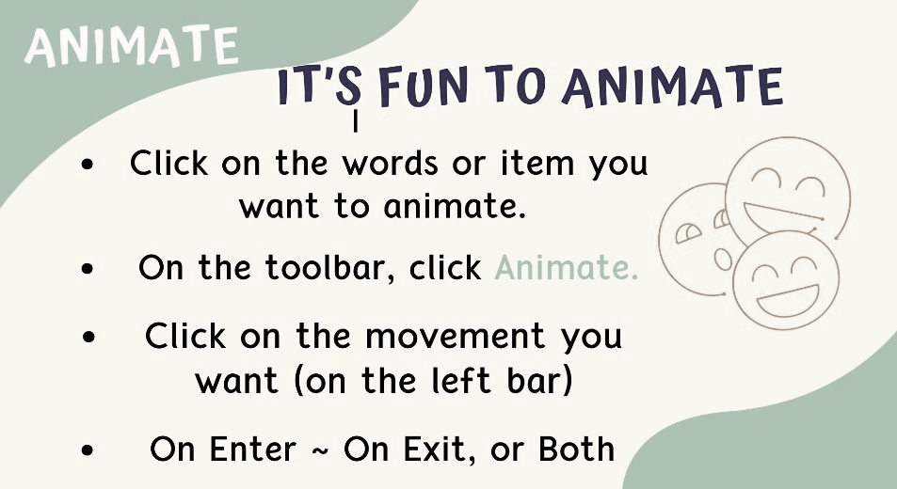
NOTES:
_____________________________________________________________________________________________________________________________________________________________________________________________________________________________________________________________________________________________________________________________________________________________________________________________________________________________________________________________________________________________________________________________________________________________________________________________________________________________________________________________________________________________________________________________________________________________________________________________________________________________________________________________________________________________________________________________________________________________________________________________________________________________________________________________________________________________________________________________________________________________________________________________________________________________________________________________________________________________________________________________________________________________________________________________________________________
____________________________________________________________________________________________________________________________________________________________________________________________________________________________________________________________________________________________________________________________________________________________________________________________________________________________________________________________________________________________________________________________________________________________________________________________________________________________________________________________________________________________________________________________________________________________________________________________________________________________________________________________________________________________________________________________________________________________________________________________________________________________________________________________________________________________________________________________________________________________________________________________________________________________________________________________________________________________________________________________________________________________________________________________________________________________________________________________

