CHILDREN’S LIT WRITING INTENSIVE
Florida Christian Writers Conference 2022
Leslie Santamaria

Thursday, October 20, 2022 1:30-3:45p

- INTRODUCTION TO CHILDREN’S PRODUCTS—FICTION AND NONFICTION

- GETTING STARTED & TOP 10 TIPS FOR SUCCESS
Exercises: Mission Statements; Generating Ideas; Writing Prompt

Friday, October 21, 2022 9:15-11:15a

- KIDLIKE CHARACTERS & DIALOGUE
Exercises: Character Sketches; Character (F)/Subject (NF) Interviews

- PLOT & STRUCTURE: 2 APPROACHES
Exercises: Problem/Solution; Beat Sheet

Saturday, October 22, 2022 9:15-11:15a

- ALL ABOUT PICTURE BOOKS
Exercise: Writing Prompt

- PLAYING WITH THE LANGUAGE
Exercise: Sensory Writing

Sunday, October 23, 2022 9:15-11:15a

- MARKETING (Special Guest)
Exercise: Platform and Marketing Treasure Chest

- SCHOOL VISITS
Exercise: School Visit Outline
Closing Celebration—with Treats!
CHILDREN’S BOOKS: AGE RANGES & GRADE LEVELS

GENERAL TERMS FOR YOUNG READERS

Toddler (Read-to-me books) Ages 1-3

Preschooler (Read-to-me books) Ages 3-5

Primary or Beginning readers Ages 6-8

Middle-grade Reader, Preteen, ‘Tween Ages 8-12

Middle School Grades 6-8, Ages 11-14

Teenager Ages 13-19

Young Adult Reader Ages 10-adult (mainly 13-18)

BOOKS

Baby Books (0-25 words*) Babies

Board Books (0-300 words*) Ages 0-4

Picture Books (0-700 words*) Ages 4-8

Nonfiction Picture Books (800-2000 words*) Ages 4-9

Easy Readers (50-2500 words*) Preschool-Grade 3, Ages 4-9

Chapter Books (4-15K words*) Grades 1-3, Ages 6-9

Young Middle Grade Novels (15K-30K words*) Grades 3-6, Ages 8-12

Middle Grade Novels (30K-50K words*) Grades 3-6, Ages 8-12

Upper Middle Grade Novels (45K-65K words*) Grades 5-8, Ages 10-14

Young Adult Novels (50K to 85K words*) Grades 7-12, Ages 13-18

*All word counts are estimates; you will find exceptions.
CONVENTIONAL AGES OF STUDENTS

GRADE AGE

1 6-7
2 7-8
3 8-9
4 9-10
5 10-11
6 11-12
7 12-13
8 13-14
9 14-15
10 15-16
11 16-17
12 17-18

CHILDREN’S BOOKS: FORMATS

BOARD BOOKS

This format lets children experiment with books. They are big enough for toddlers to grab and manipulate, and the content helps them make connections between hearing words and seeing pictures. Not every page must be read; a random order of experiencing the pages is fine.

- Pages are thick cardboard or cardstock
- types: concept, nursery rhyme, wordless, question-and-answer
- often made from popular picture books that translate well to a younger readership
- interactive, sometimes with novelty features
- sometimes written in-house
- sell well and make great gifts
- word count: 0-300
- age range: 0-4
- Examples: Brown Bear, Brown Bear, What Do You See? by Bill Martin Jr. and Eric Carle; Trunk or Treat by Michelle Medlock Adams and Marilee Harrald-Pilz

PICTURE BOOKS

This is the format most people think of when they talk about children’s books.

- distinctive works of art
- highly illustrated
- the pictures are not redundant to the story but must tell 50% of the story
- illustrated by professional artists, not necessarily the author of the text
- most are 32 pages (the next most common lengths are 16, 24, 48)
- target audience is typically ages 4-8
- text is lively, active, and engaging
- simple, clear plot based on a single situation and told from a child’s viewpoint
- word count: 0-700; shorter is better! most editors want only 600 or 500 or 300 words; Editor Mary Kole says 600 max
- Examples: Don’t Let the Pigeon Drive the Bus! by Mo Willems, Where the Wild Things Are by Maurice Sendak, Pete the Cat by James Dean, Kimberly Dean, and Eric Litwin

PICTURE STORYBOOKS

Many of these are older titles. Of the newer titles, many are nonfiction and/or written by established authors. This is a hard sell for a debut author. Most importantly, manuscripts at this length can often be shortened to a standard picture book length.

- word count up to 1500+
- slightly older age group; slightly more involved plot
- Examples: Patricia Polacco books like Pink and Say, Max Lucado’s You Are Special and You Are Mine

READERS (EASY, EARLY, and LEVELED)

- 6 x 9 trim size
- vertical orientation
- typically 32 to 64 pp
- heavily illustrated
- simple text at a specific reading level; often in leveled series
- for emerging readers
- focus on phonics
- short words, sentences, and paragraphs; sometimes broken into short chapters
- content is lighthearted, often character-based
- limited number of characters, but interesting plot and characters to keep the reader engaged
- reader gets clues from the pictures, so they must match text
- often written in-house or by assignment
- word count: 50-2500
- age range: 4-9 (Preschool-Grade 3)
- Examples: I Can Read books (Harry the Dirty Dog, Frog and Toad); Step into Reading books (No Mail for Mitchell); Hello Reader! books (Amelia Bedelia); Ready to Read (Susan B. Anthony: Fighter for Women’s Rights)

CHAPTER BOOKS

- primarily tells the story through words rather than pictures
- some spot art
- more complex stories and characters
- word count: 4,000-15,000 (wide range)
- age range: 6-9
- Examples: Clementine by Sara Pennypacker, Ivy & Bean by Annie Barrows, Geronimo Stilton, Junie B. Jones by Barbara Park, Magic Tree House by Mary Pope Osborne, Captain Underpants by Dav Pilkey

MIDDLE GRADE NOVELS

- focus on friends, family, and the character’s immediate world and his/her relationship to it (In contrast, YA characters discover how they fit in the larger world, beyond friends and family.)
- characters react to what happens to them; minimal self-reflection
- protagonist is age 10-13
- clean & wholesome; no profanity, graphic violence, or sexuality (romance, if any, is limited to a crush or a first kiss at most—in the general market)
- word count: young MG 15K-30K; middle MG 30K-50K; upper MG 45-65K
- age range: 8-12 (10-14 for upper MG)
- grades: 3-8 (upper elementary mostly; not necessarily “middle school”)
- Examples: Because of Winn-Dixie by Kate DiCamillo, From the Mixed-Up Files of Mrs. Basil E. Frankweiler by E.L. Konigsburg, Merci Suarez Changes Gears by Meg Medina

YOUNG ADULT NOVELS

- YA characters discover how they fit in the larger world, beyond friends and family
- reflecting on self and what happens in the world
- often told in first person
- profanity, graphic violence, romance, and sexuality are allowable in general market
- complex story lines and read like adult novels, except with topics teens are interested in
- verse novels are popular
- protagonist is age 14-19
- readers’ age range: 13-18+
- Examples: Purple Moon by Tessa Emily Hall, books by Jenny B. Jones, Bryan Davis, When Rain Falls Down by Angela Jackson Brown, the Hunger Games series by Suzanne Collins; To Stay Alive (verse novel) by Skila Brown

KIDLIT LINGO

4 SEGMENTS OF PUBLISHING FOR CHILDREN

1. Books

2. Periodicals: print and online magazines and newspapers (anything printed periodically on a regular schedule)

3. Educational markets: curricula and/or supplemental teaching materials for public school, private school, homeschool, Sunday School, VBS

4. Scripts: plays, video scripts, film scripts, gaming scripts; this often overlaps with the educational markets

TYPES OF WRITING

1. Fiction
realism, fantasy, magical realism (Crenshaw by Katherine Applegate, Savvy by Ingrid Law), sci-fi, mystery, historical, contemporary, futuristic

2. Nonfiction
concept books (teach educational concepts), biographies, slew of formats teaching science, history, math, etc.

GENRE vs. CATEGORY vs. FORMAT

1. Genre relates to the content: fiction, nonfiction, fantasy, mystery, adventure (also: romance, horror, and thriller in the adult market)

2. Category refers to the age group or reading level: board books, picture books, middle grade (not middle school), young adult

3. Format refers to the physical features of the books: hardcover, softcover, trim size, paper type (paper, cardboard), colors (black & white, full color, spot color), special features (pop-up, lift-a-flap, peek-a-boo book)
HOMING IN ON THE FORMAT FOR YOUR IDEA

- What is the age of your target audience?
- What types of books does your target audience read?
- Will this story be read aloud to the child exclusively?
- Will the story rely heavily on illustrations to communicate part of the plot or a subplot?
- Do you intend for the reader to learn how to read using your story?
- Do you intend for the child to be able to read the text independently?
- What age is your main character? (Remember: Kids “read up.”)
- Is your intended reader a new or experienced reader?
- Is the plot simple or does it include subplots?
- Is the story primarily focused on the main character’s family, friends, and immediate world?
- Is the main character discovering how he or she fits in the larger world, beyond friends and family?
- Is the main character highly self-reflective?

CHARACTER SKETCH

Name:

Nickname(s):

Age:

Heritage:

Physical description:

Clothing style:

Resembles:

Family (including pets):

Where does she live?:

Home:

Bedroom:

Occupation/education:

Favorite things (colors, foods, numbers, etc.—whatever is important to the story):

Loves:

Hates:

Fears:

Friends:

Enemies:

Beliefs:

Quirks:

Special sayings:

Emotional characteristics:

Special abilities/what makes her unique:

Strengths:

Why a reader will care about this character:

Backstory:

Ordinary World at the start of the story:

Long-term life goals:

Secret:

Deepest longing at the start of the story:

What she dreads throughout the story:

SAVE THE CAT! MODEL:

Problem (or flaw that needs fixing):

Want (goal character is pursuing):

Need (or life lesson to be learned):

GMC MODEL:

External story goal (Goal):

Why she wants this external story goal (Motivation):

What stands in her way of this external story goal (Conflict):

Internal story goal (Goal):

Why she wants this internal story goal (Motivation):

What stands in her way of this internal story goal (Conflict):

CHARACTER INTERVIEW

How old are you?

Where do you go to school?

Do you like school?

What’s your favorite or least-favorite part of school?

How are things at home?

Who is your favorite family member and why?

What do you wish you could change about your family?

What kind of childhood did you have?

What do you want to be when you grow up?

Who is your best friend and why?

What historical or contemporary figure do you admire and why?

Author Jan Eldredge’s 4 questions:

- What’s your passion?
- What do you want right now?
- What do you fear?
- What change needs to happen in your self or your life?

Leslie’s additional question:

- What’s your secret?
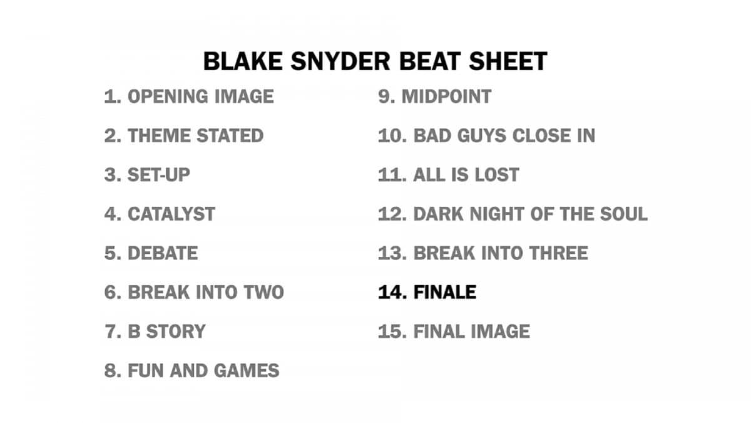

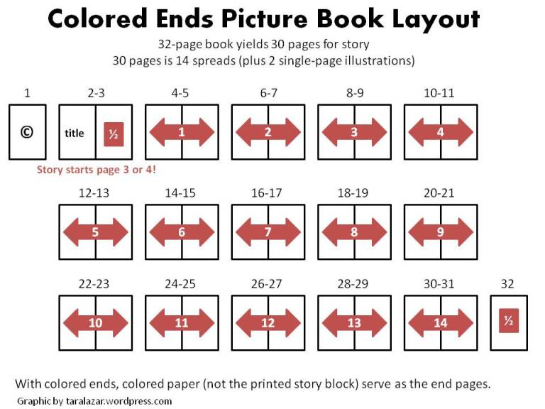
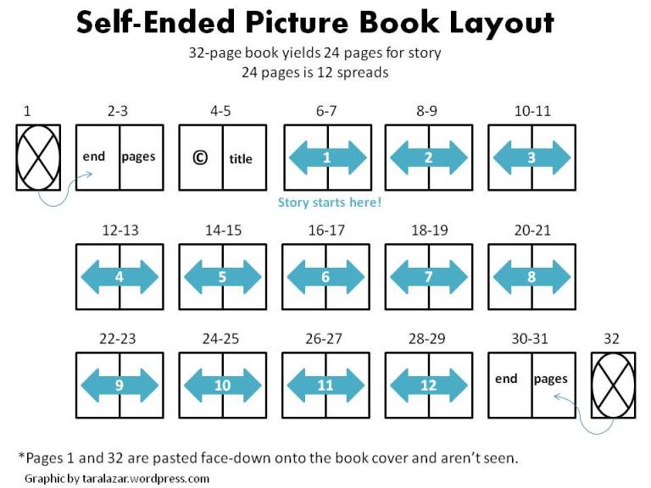

REVISION CHECKLIST

Check the structure of the story arc.
Does the story begin in the right place?
Does it start with a hook, followed quickly by an inciting incident?
Can you name the turning points?
Does the middle sag or propel your reader to the climax?
Does it appear as though the protagonist won’t succeed?
Is the climax exciting enough? Believable?
Is the resolution complete or does it leave dangling threads?
Is the end satisfying?
Is there enough action and conflict?

Check the timeline. Is it clear to the reader?

Check the progression of your protagonist’s character arc.
Is her goal clear?
Is her motivation clear and believable?
Are her actions consistent with her motivations?
Is her weakness or misunderstanding clear in the beginning?
Does she try and fail and try again throughout the story?
Does she face her fear and then solve her own problem?
Does she grow believably?
Is there enough interior monologue?
Is she likable? Will the reader pull for her to succeed?

Check the development of minor characters.
Are they well rounded, if appropriate?
Are the flat characters flat because that is appropriate?
Do the character voices sound distinct?

Check the viewpoint. Is it consistent?

Consider the pacing.
Are the scenes well developed with clear actions, goals, and character turns?
Are the transitions in and out of scenes smooth?
Is the action fast-paced?
Are there appropriate sequels after scenes?
Is anything slow and/or boring?

Reread the setting descriptions. Are they well rendered with a minimum of description?

Highlight the sections of backstory and review. Is it sprinkled in with a light touch, as needed?

Read the dialogue out loud.
Is it believable and engaging?
Is there too much or too little?
Are there dialogue tags that can be removed?
Are there sufficient action beats to ground the reader and vary the pace?

Read the sentences closely.
Is there “telling” that should be converted to “showing”?
Are the sentence structures varied?
Are the word choices fresh and interesting?
Is the writing clear and effective?
Is the writing lovely?

Proofread every word and punctuation mark.

RESOURCES

12 x 12 Challenge for Picture Book Writers: www.12x12challenge.com.

100 Most Frequent Words in Books for Beginning Readers: http://en.copian.ca/library/research/100most/100most.pdf.

Accelerated Reader Book Find: www.arbookfind.com. Look up word counts, publication information, and ATOS reading levels of published books.

Ashman, Linda. The Nuts and Bolts Guide to Writing Picture Books. This extensive booklet is available through her website: www.lindaashman.com.

Christensen, Evelyn. http://evelynchristensen.com/index.html. Up-to-date lists of children’s magazines and educational markets, plus articles and tips for writers.

Dolch Sight Words: https://sightwords.com/sight-words/dolch/#lists.

Jones, Amy, editor. Children’s Writer’s and Illustrator’s Market 33rd Edition. Writer’s Digest Books, 2022.

Kidlit411: www.kidlit411.com. This blog contains a wealth of information.

Kole, Mary. Writing Irresistible Kidlit. Writer’s Digest Books, 2012.

Lamba, Marie. “The Key Differences Between Middle Grade and Young Adult.” Writer’s Digest, August 7, 2014. https://www.writersdigest.com/online-editor/the-key-differences-between-middle-grade-vs-young-adult.

LiteraryDevices Editors. https://literarydevices.net/. An extensive list of literary techniques, with a lot of ads on the website, unfortunately.

Poetry Foundation. “Glossary of Poetic Terms.” https://www.poetryfoundation.org/learn/glossary-terms. This website is chock-full of resources for poets, including an extensive list of literary devices, with no ads.

Shaffer, Sylvie. “New for New Readers: What (Exactly) Is An Easy Reader.” The Horn Book, May 12, 2019. https://www.hbook.com/?detailStory=what-exactly-is-an-easy-reader.

Society of Children’s Book Writers and Illustrators (SCBWI): www.scbwi.org.

Society of Children’s Book Writers and Illustrators (SCBWI). The Book: Essential Guide to Publishing for Children 2020. *Available to members only.

Storystorm Challenge: https://taralazar.com/storystorm/

Underdown, Harold. “Writing, Illustrating, and Publishing Children’s Books: The Purple Crayon.” https://www.underdown.org/ This website contains a wealth of information.

“What Are Readability Formulas?”
https://readabilityformulas.com/articles/what-are-readability-formulas.php.

“What Is ATOS?” https://www.renaissance.com/edwords/atos/.

