Message Driven Fiction Instead of Memoir

By Shellie Arnold

Session 1: Truth, Takeaway, Tying into Platform

1. What truth do you want to share with others through your novel?

2. During what experience did you learn this lesson?

3. How was your mindset or relationship with God different before that experience and learning this truth?

4. How has your life and relationship with God changed since the experience and learning this truth?

5. What is your takeaway? (Lesson/truth>message>takeaway = you>God>reader)

Ex. from The Spindle Chair.
Lesson/truth: Pain from our past can cause trouble today in our marriage.
Message: God can heal our pain.
Takeaway: I can choose to let God heal my pain, and that work will benefit my marriage.

6. Tying into platform:

Ex. from The Spindle Chair. Pro-life, marriage, Pierce>trauma, forgiveness, inner healing, God’s sovereignty, Laurie>expectations in marriage/trusting God’s work in self and mate, abandonment & rejection.

*Consider these while you’re planning your book and as you write. More will surface during the writing.

Message Driven Fiction Instead of Memoir

By Shellie Arnold

Session 2: Pitfalls, Characters, Plotline

Pitfalls with message driven fiction:

1. The book is too preachy.

2. Your character is too much in her head.

3. Your character doesn’t have a real problem.

4. Your character has too many problems.

5. Your character experiences real trauma, but you gloss over it.

6. Your character solves her problems too easily.

7. Book is full of Christian-speak and cliches.

8. Every supporting character is nice or snarky.

9. Weak backstory for your character.

*See Michael Hauge’s plot structure
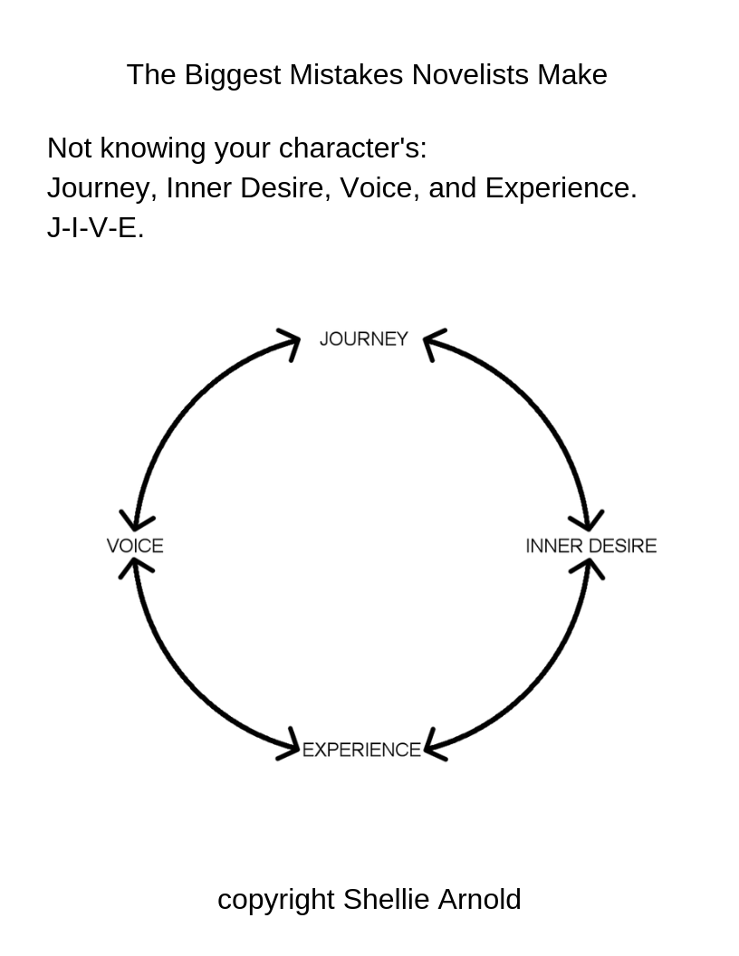

Worksheet for Michael Hauge’s Six Stage Plot Structure

Title of story or movie: _________________________________________________________

0%: Where does the story begin?

Where is the main character internally?

Where is the main character externally?

10%: What is Turning Point #1? (Opportunity)

Where is the main character internally?

Where is the main character externally?

25%: What is Turning Point #2? (Change of Plans)

Where is the main character internally?

Where is the main character externally?

50%: What is Turning Point #3? (Point of No Return)

Where is the main character internally?

Where is the main character externally?

75%: What is Turning Point #4? (Major Setback)

Where is the main character internally?

Where is the main character externally?

90%-99%: What is Turning Point #5? (Climax)

Where is the main character internally?

Where is the main character externally?

100%: How does the story end?

Where is the main character internally?

Where is the main character externally?

**Adapted from Michael Hauge’s Six Stage Plot Structure
www.ScreenplayMaster.com

Message Driven Fiction Instead of Memoir

By Shellie Arnold

Session 3: Brainstorming

1. What truth do you want to share with others through your novel?

2. During what experience did you learn this lesson?

3. How was your mindset or relationship with God different before that experience and learning this truth?

4. How has your life and relationship with God changed since the experience and learning this truth?

5. What is your takeaway? (Lesson/truth>message>takeaway = you>God>reader)

Ex. from The Spindle Chair.
Lesson/truth: Pain from our past can cause trouble today in our marriage.
Message: God can heal our pain.
Takeaway: I can choose to let God heal my pain, and that work will benefit my marriage.

